Parth Babbar

Saving account

**Introduction:**

A savings account is a fundamental financial instrument accessible at banks and credit unions across the country, providing a secure depository for assets as well as the opportunity to earn moderate interest. This study digs into the complexities of savings accounts in the United States, including their characteristics, benefits, legal structure, and statistical data. These accounts, designed for collecting savings rather than everyday transactions, promote fund growth by generating interest on deposited balances, therefore supporting long-term financial objectives.

**Features of Saving Account:**

1. **Interest Rates:** Savings accounts often have variable interest rates that are higher than those of checking accounts, but lower than those given by investment choices such as certificates of deposit (CDs). These rates might vary significantly according on the financial institution, so savers should research choices to maximise their gains over time.
2. **Limited Transactions:** Accessing cash from a savings account is straightforward, but federal laws limit some withdrawal types to 6 per month. These restrictions are intended to encourage saving habits by preventing excessive withdrawals, supporting stability and long-term financial planning.
3. **FDIC Insurance:** Savings accounts are protected by either the Federal Deposit Insurance Corporation (FDIC) or the National Credit Union Administration (NCUA), which guarantees savings up to $250,000 per depositor, per insured bank or credit union. This insurance gives account holders peace of mind by safeguarding their cash from future bank failures or financial turmoil.
4. **Minimum Balance:** Many savings accounts demand a minimum balance to avoid fees and receive interest.
5. **Online & Mobile Banking:** Allows for easy management of savings, transfers, and interest generated.

**Types of Saving Account:**

1. **Traditional Savings Accounts:** Basic accounts with low interest rates.
2. **High-Yield Savings Accounts:** These accounts often provide greater interest rates and are available through online banks.
3. **Money Market Accounts:** Typically have greater interest rates but restricted check-writing capabilities.
4. **Certificates of Deposit (CDs):** Fixed-term savings accounts that pay higher interest rates but limit access to cash until maturity.

There are few more types like online saving account, student saving account, cash management account, etc.

**Benefits of Saving Account:**

1. **Security:** FDIC or NCUA insurance covers deposited cash in the event of a bank or credit union failure.
2. **Interest Earnings:** Although small, interest generated on savings accounts provides a risk-free return on deposited cash.
3. **Financial Goals:** Savings accounts are suitable for meeting short-term financial objectives such as emergency cash, vacations, or large expenditures.
4. **Convenience:** Savings accounts are ideal for managing day-to-day expenses and unforeseen bills since they provide easy access to cash.

**Statistics:**

1. In 2023, the United States had around 460 million savings accounts in various institutions, reflecting its broad use. Nearly 98.6% of American families have transaction accounts, which includes savings accounts, demonstrating its importance in personal finance.
2. The average sum in savings accounts varies by demography, although it is typically between $5,000 and $10,000 per account.  
   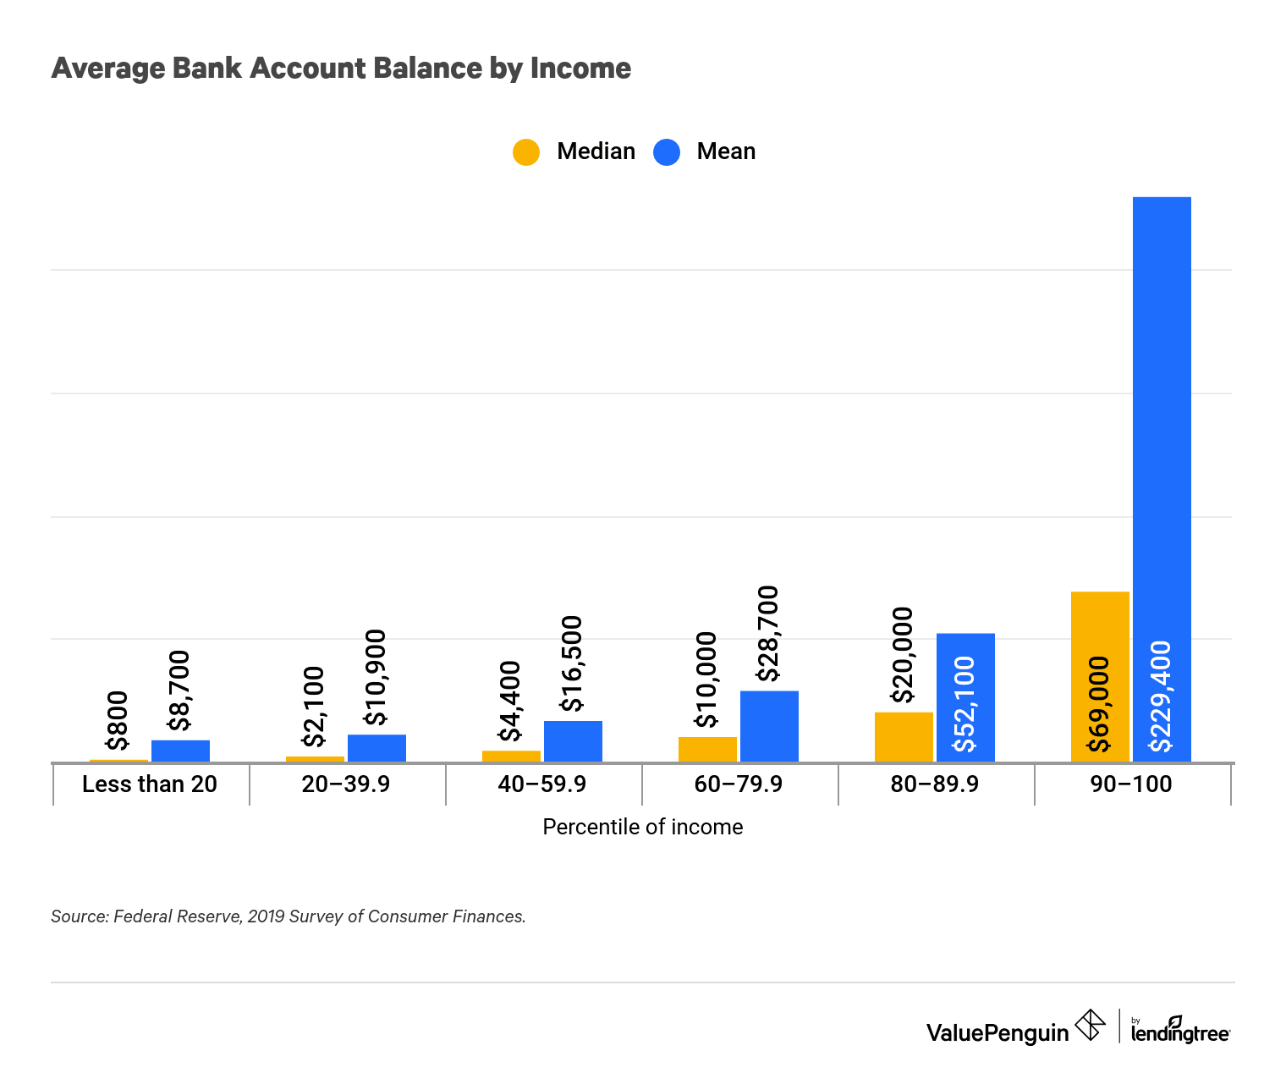
3. In recent years, average savings account interest rates have varied between 0.05% and 0.50%, determined by Federal Reserve policies and market conditions.  
   **A screenshot of a computer

   Description automatically generated**  
   Even when federal interest rates rise, many traditional savings accounts continue to give a low annual percentage yield. Savings accounts at Bank of America, for example, offer between 0.01% and 0.04% APY, depending on the customer's account status. Chase also only gives an annual percentage yield (APY) ranging from 0.01% to 0.02%, depending on the kind of savings account and client connection with the bank.

**Conclusion:**

Savings accounts serve an important part in the United States' financial ecosystem, providing a secure and accessible means for people to save money and receive interest. With strong regulatory monitoring and comprehensive consumer safeguards, savings accounts remain a popular choice among Americans for short-term savings and emergency money.